UNIVERSITY OF TRANSPORT HO CHI MINH CITY


Description of the Student Management System

Full name | Student ID | Role
Hà Văn Bảo | 051203014096 | Leader + Requirement specifications + Design
Lê Hoàng Minh Khang | 082206004707 | Draw DFD
Phạm Nguyễn Gia Bảo | 079206004263 | Draw Use Case Diagrams
Lê Thế Huy | 083206000728 | Draw Class Diagrams
Nguyễn Nhật Toàn | 079206045477 | Requirement specifications + Design

Document Change Record:

Date | Version | Describe | Author
7/4/2026 | 1.0 | Create documentation describing functional and non-functional requirements. Draw DFD diagrams, use case diagrams, and class diagrams.  Design the database, format tables, primary keys, and foreign keys.

Functional Requirements

The Student Management System is a console-based application designed to manage students, teachers, courses, and academic activities efficiently. The system allows different types of users (students, teachers, and administrators) to interact with the system through a command-line interface using keyboard input.
The following subsections describe the functional requirements of the system in detail.

Student Functions

1.1. Update Personal Information
Description
The system shall allow students to update their personal information.
Input
The student enters:
- Full name
- Phone number
- Email
- Address
Processing
- The student logs into the system.
- The system displays the main menu.
- The student selects the “Update Personal Information” option.
- The system prompts the student to enter updated information via the console.
- The system validates all input data (e.g., email format, non-empty name).
- If valid, the system updates the information in the database.
Output
- The system prints a confirmation message indicating that the update is successful.

1.2. Change Password
Description
The system shall allow students to change their account password.
Input
The student enters:
- Current password
- New password
- Confirm new password
Processing
- The student selects “Change Password” from the menu.
- The system prompts the student to enter the current password.
- The system verifies the current password.
- The student enters a new password and confirms it.
- The system checks:
  - New password matches confirmation
  - Password meets security requirements
- If valid, the system updates the password in the database.
Output
- The system prints a success or error message.

1.3 Register for Courses
Description
The system shall allow students to register for available courses.
Input
- Course ID
Processing
- The student selects “Register Course”.
- The system displays available courses.
- The student enters a course ID.
- The system checks:
  - Course availability
  - Capacity limit
  - Schedule conflicts
- If valid, the system stores the registration.
Output
- The system prints success or failure messages.

1.4. View / Modify Registered Courses
Description
The system allows students to view or modify registered courses.
Processing
- The student selects “View Registered Courses”.
- The system retrieves and prints the list of registered courses.
- The student selects a course to modify (e.g., cancel).
- The system updates the registration if allowed.
Output
- Updated course status is printed.

1.5. View Tuition Fees
Description
The system allows students to view tuition fee information.
Processing
- The student selects “View Tuition Fees”.
- The system retrieves tuition data.
Output
- The system prints:
  - Total fee
  - Paid amount
  - Remaining balance

1.6. View Schedule
Description
The system allows students to view their study schedule.
Processing
- The student selects “View Schedule”.
- The system retrieves schedule data.
Output
- The system prints schedule details (date, time, course).

1.7. View Notifications
Description
The system allows students to view notifications.
Processing
- The student selects “View Notifications”.
- The system retrieves notification data.
Output
- The system prints all notifications.
- Teacher Functions

2.1. Update Personal Information
Description
The system shall allow teachers to update their personal information.
Input
The teacher enters:
- Full name
- Phone number
- Email
- Address
Processing
- The teacher logs into the system.
- The system displays the main menu.
- The teacher selects “Update Personal Information”.
- The system prompts input via console.
- The system validates data.
- The system updates the database.
Output
- A confirmation message is printed.

2.2. Change Password
Description
The system shall allow teachers to change their password.
Input
- Current password
- New password
- Confirm password
Processing
- The teacher selects “Change Password”.
- The system verifies the current password.
- The teacher enters a new password.
- The system validates and updates.
Output
- A success or error message is printed.

2.3. View Teaching Schedule
Description
The system allows teachers to view their teaching schedule.
Processing
- The teacher selects “View Schedule”.
- The system retrieves data.
Output
- Teaching schedule is printed.

2.4. View Student List
Description
The system allows teachers to view students in their courses.
Processing
- The teacher selects a course.
- The system retrieves student list.
Output
- Student list is printed.

2.5 Input Grades and Feedback
Description
The system allows teachers to assign grades and feedback.
Input
- Student ID
- Grade
- Comment
Processing
- The teacher selects “Input Grades”.
- The system prompts input via console.
- The system validates grade values.
- Data is stored.
Output
- Confirmation message is printed.

2.6 View Notifications
Description
The system allows teachers to view notifications.
Processing
- The teacher selects “View Notifications”.
- The system retrieves data.
Output
- Notifications are printed.

Admin Functions

View Teacher List
Description
The system allows admin to view all teachers.
Processing
- Admin selects “View Teachers”.
- The system retrieves data.
Output
- Teacher list is printed.
  - View Student List
Description
The system allows admin to view all students.
Processing
- Admin selects “View Students”.
- The system retrieves data.
Output
- Student list is printed.

Manage Courses
Description
The system allows admin to manage courses.
Processing
- Admin selects “Manage Courses”.
- The system displays options:
  - Create course
  - View courses
  - Approve registrations
- Admin enters data via console.
- System updates database.
Output
- Updated course list is printed.

Create User Accounts
Description
The system allows admin to create accounts.
Input
- Username
- Password
- Role
Processing
- Admin selects “Create Account”.
- The system prompts input.
- The system validates and stores data.
Output
- Account creation message is printed.

Manage Tuition Fees
Description
The system allows admin to manage tuition.
Processing
- Admin selects “Check Tuition”.
- The system retrieves unpaid students.
- Admin can mark payment or send reminder.
Output
- List of unpaid students is printed.
- Non-functional requirement

Usability
The system shall provide a console-based interface with clear menu options. Users interact using keyboard input.
The system shall:
- Display numbered menus
- Provide step-by-step instructions
- Print clear success/error messages

Performance
The system shall:
- Process operations quickly
- Handle multiple users efficiently
- Use minimal resources in console environment

Security
The system shall:
- Require login authentication
- Support role-based access control
- Validate all user inputs

Reliability
The system shall:
- Operate without crashing
- Handle errors gracefully
- Maintain data integrity

Maintainability
The system shall use modular design:
- User module
- Course module
- Tuition module
- Schedule module

Scalability
The system shall support increasing:
- Number of users
- Courses
- Data
without performance issues.

- DFD diagrams
- Student management level 0
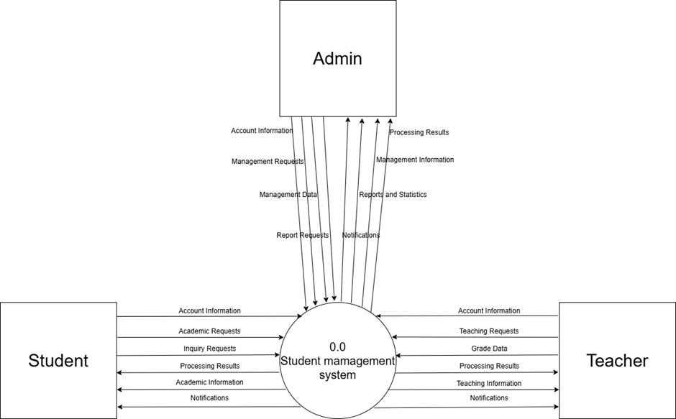
- Student management level 1
2.1 1.0 Account Management
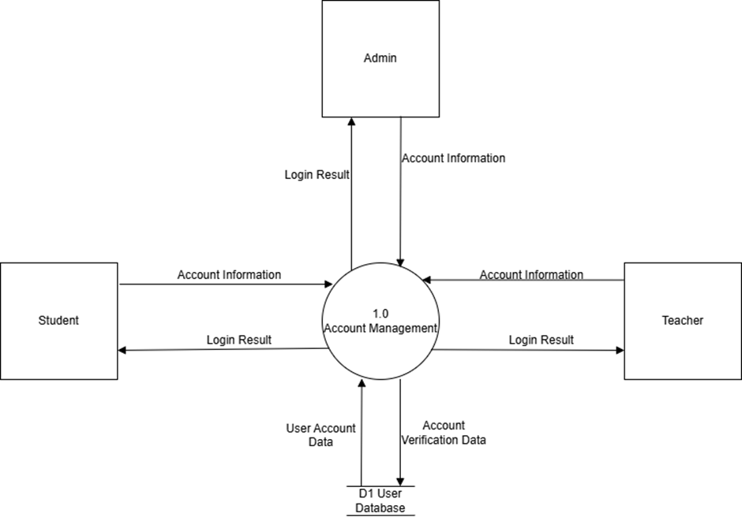
2.2 2.0 Personal Information Management
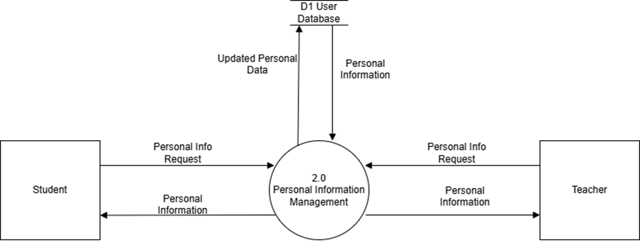
2.3 3.0 Course Registration Management
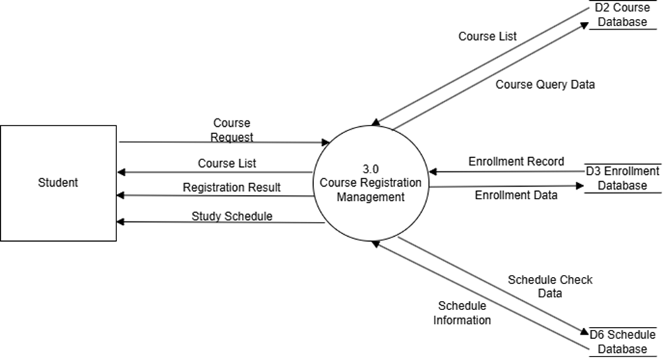
2.4 4.0 Grade Management
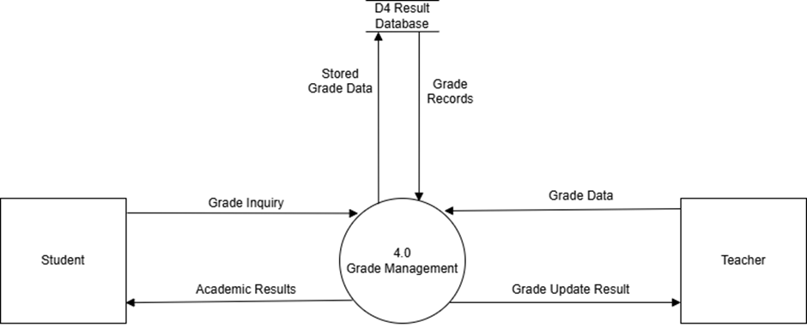
2.5 5.0 Tuition Management
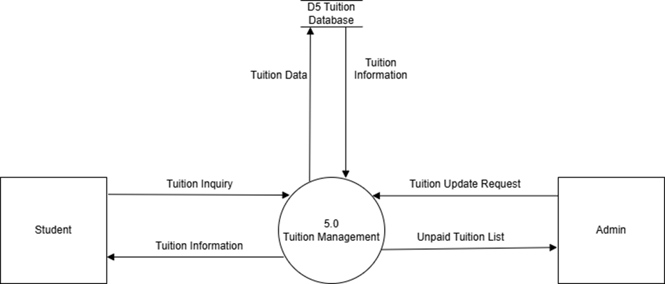
2.6 6.0 Report and Notification Management
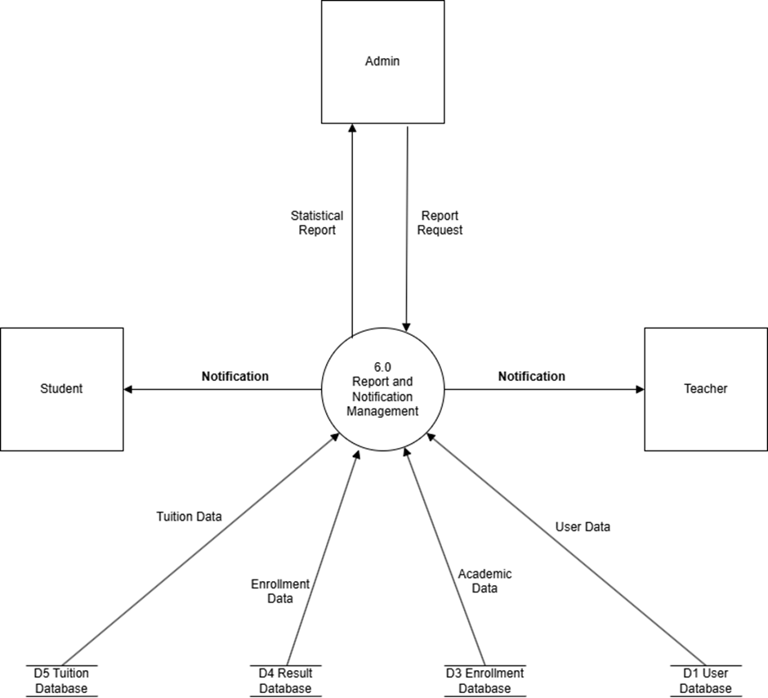
- Student management level 2
3.1 1.0 Account Management
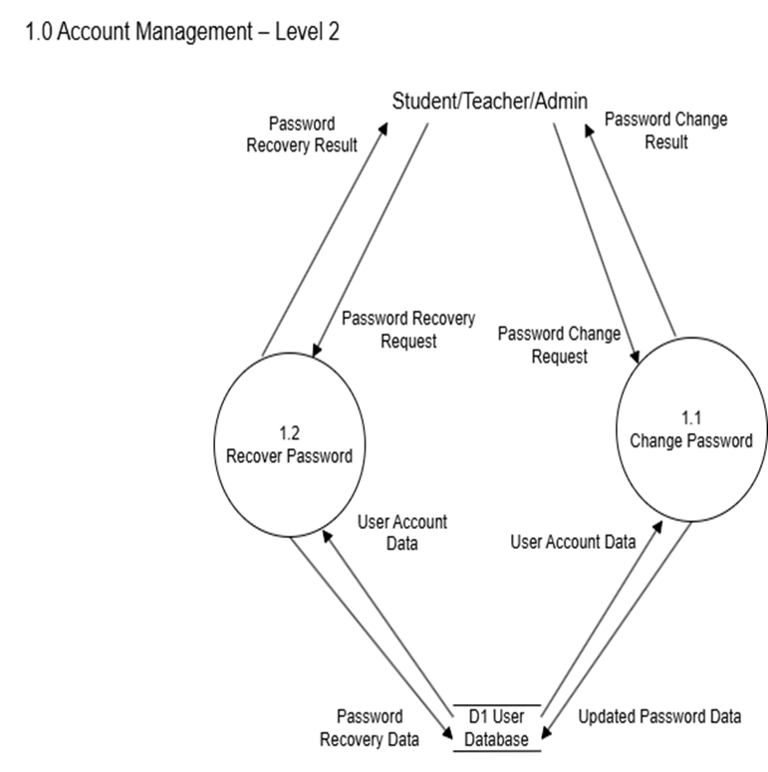
3.2 2.0 Personal Information Management
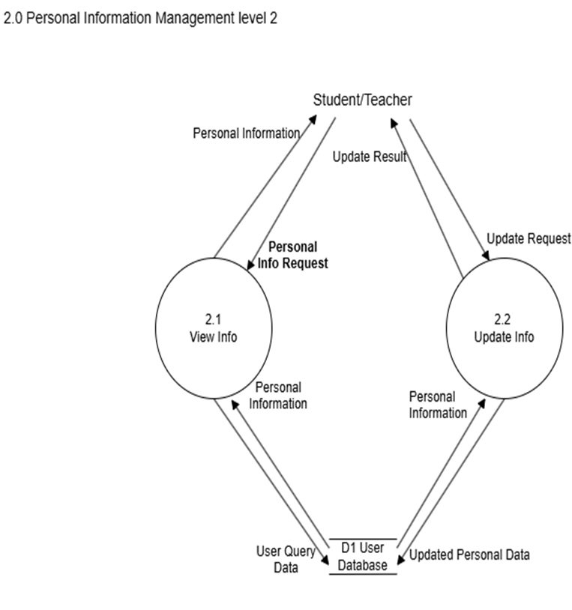
3.3 3.0 Course Registration Management
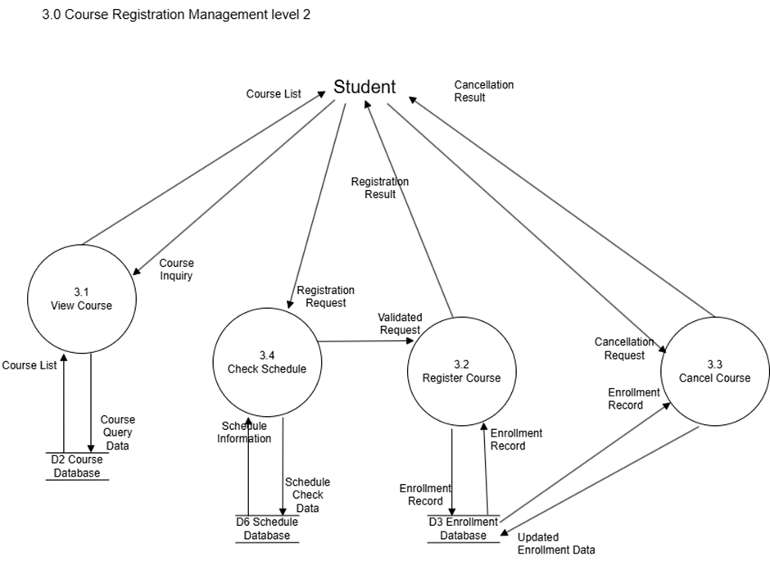
3.4 4.0 Grade Management
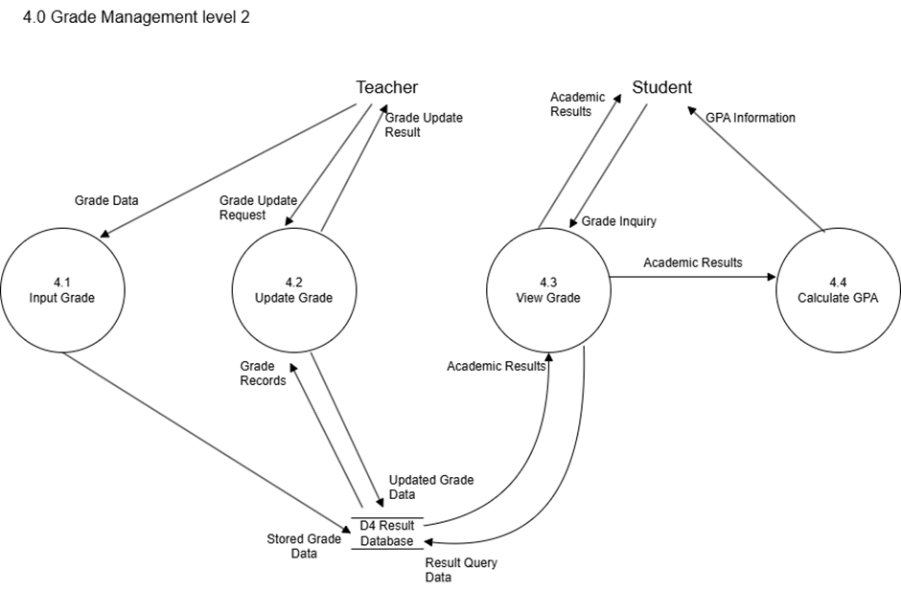
3.5 5.0 Tuition Management
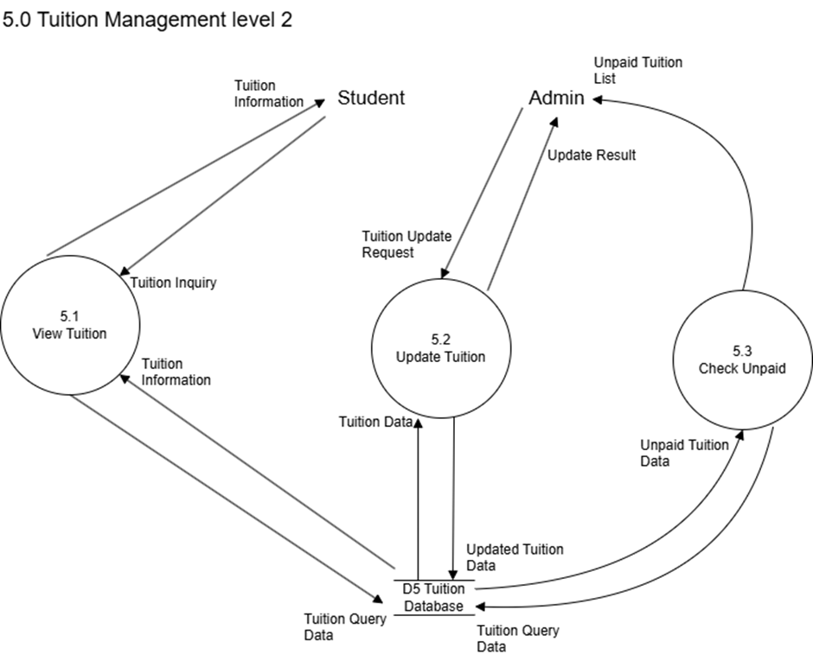
3.6 6.0 Report and Notification Management
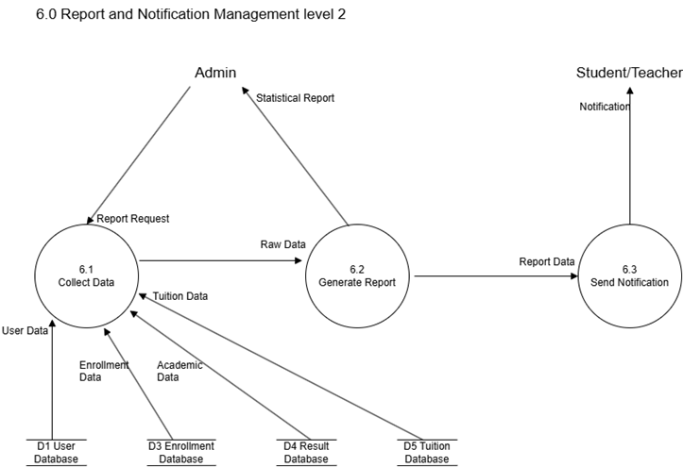
- Use case diagrams
4.1 Overview diagram

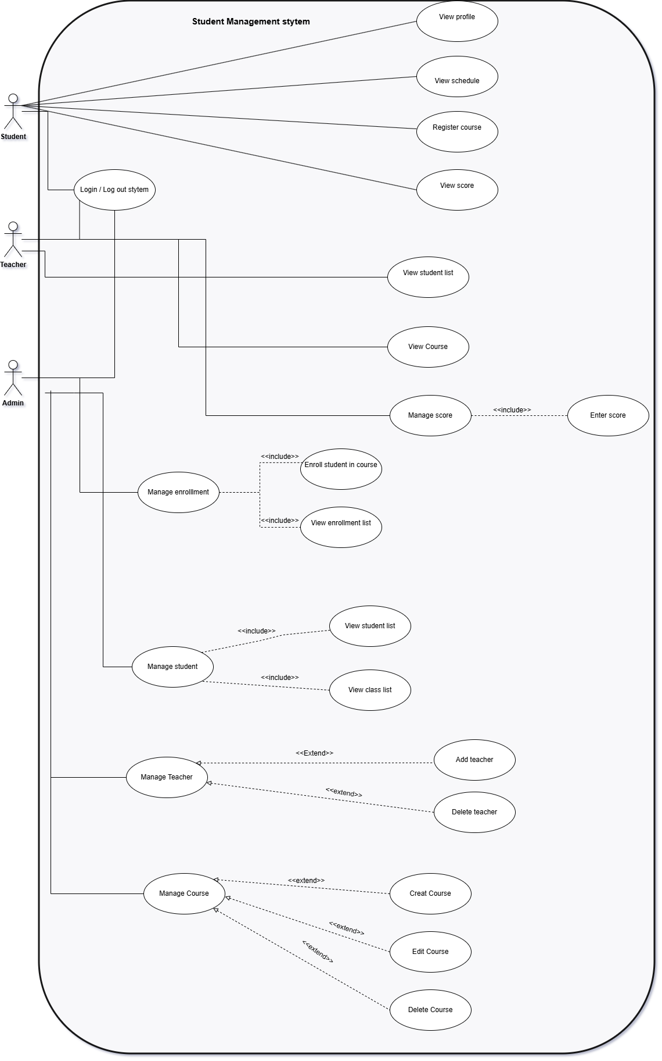

4.2 List of Actors

STT | Actor | Description
1 | Admin | Use the system to manage teachers and students.
2 | Teacher | Use the system to view student lists, manage courses, and enter student scores
3 | Student | Use the system to view personal information, register courses, and check academic results

4.3 Use-Case List

4.3 Use Case List
No | Use Case | Description
1 | Login | User logs into the system
2 | View Profile | Student views personal information
3 | View Schedule | Student views timetable
4 | Register Course | Student registers courses
5 | View Score | Student checks scores
6 | View Student List | Teacher/Admin views students
7 | View Course | Teacher views courses
8 | Enter Score | Teacher enters scores
9 | Manage Score | Admin manages scores
10 | Manage Student | Admin manages students
11 | Manage Teacher | Admin manages teachers
12 | Manage Course | Admin manages courses
13 | Manage Enrollment | Admin manages enrollments

4.3.1 Use Case: Login

Summary

This use case allows users to log into the system using their accounts.

Main Flow

The user selects the Login function

The system displays the login form

The user enters account information

The system validates the input

If valid, access is granted

Alternative Flow

If the input is invalid, the system displays an error message

4.3.2 Use Case: View Profile

Summary

This use case allows students to view their personal information.

Main Flow

The student selects View Profile

The system displays personal information

4.3.3 Use Case: View Schedule

Summary

This use case allows students to view their timetable.

Main Flow

The student selects View Schedule

The system displays the timetable

4.3.4 Use Case: Register Course

Summary

This use case allows students to register for courses.

Main Flow

The student selects Register Course

The system displays available courses

The student selects a course

The system saves the registration

4.3.5 Use Case: View Score

Summary

This use case allows students to view their academic results.

Main Flow

The student selects View Score

The system displays the results

4.3.6 Use Case: Enter Score

Summary

This use case allows teachers to enter student scores.

Main Flow

The teacher selects Enter Score

The teacher selects a student

The teacher inputs the score

The system saves the data

4.3.7 Use Case: Manage Score

Summary

This use case allows the admin to manage student scores.

Main Flow

The admin selects Manage Score

The system displays score data

The admin updates information if necessary

4.3.8 Use Case: Manage Student

Summary

This use case allows the admin to manage student information.

Main Flow

The admin selects Manage Student

The admin performs add/edit/delete operations

The system updates the database

4.3.9 Use Case: Manage Teacher

Summary

This use case allows the admin to manage teacher information.

Main Flow

The admin selects Manage Teacher

The admin performs add/delete operations

The system updates the data

4.3.10 Use Case: Manage Course

Summary

This use case allows the admin to manage courses.

Main Flow

The admin selects Manage Course

The admin performs create/edit/delete operations

The system saves the changes

4.3.11 Use Case: Manage Enrollment

Summary

This use case allows the admin to manage course enrollments.

Main Flow

The admin selects Manage Enrollment

The admin enrolls students into courses

The admin views enrollment lists

The system updates the data

Student Management System | Version: 1.0
Describe System | Date: 7/4/2026
- Class diagrams
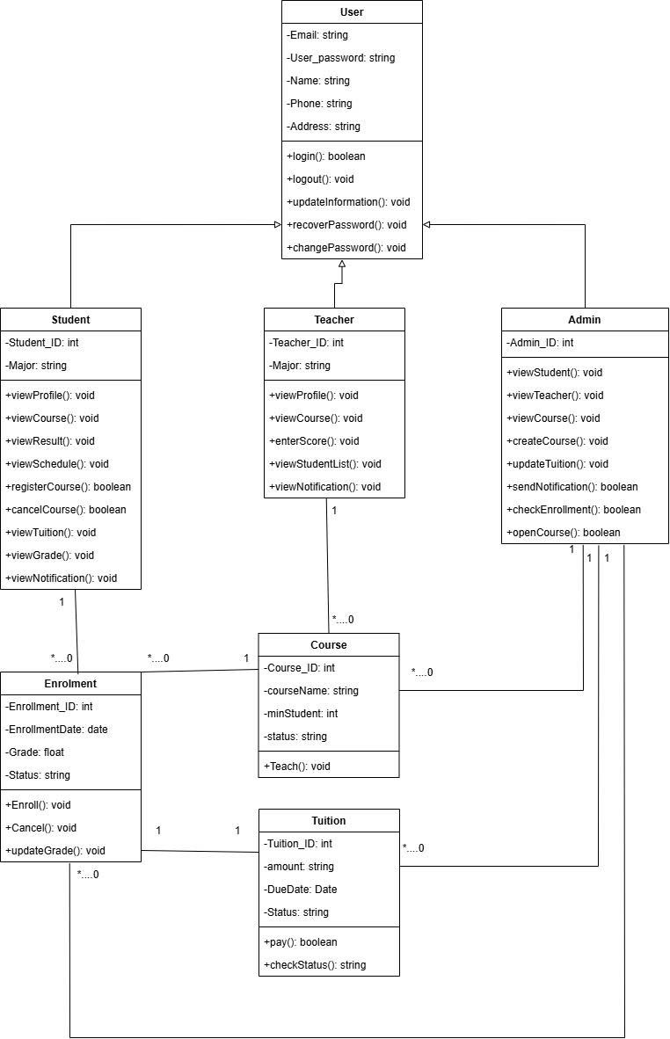

- Data model
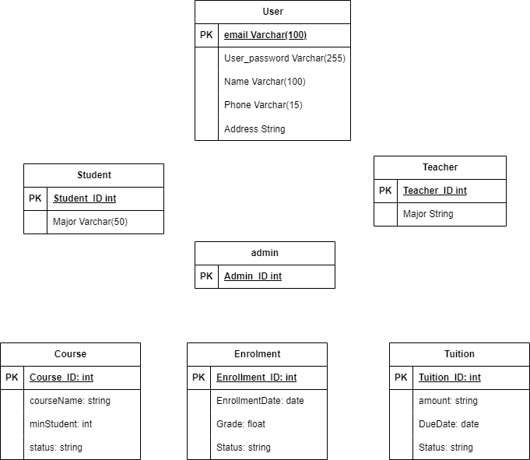

- Interface design description
Main menu
=== STUDENT MANAGEMENT SYSTEM =====
1.1. Login
1.2. Forgot Password
1.3. Exit
Student Menu (Level 3)
2.1. View profile - id
2.2. View score
2.3. View Courses
2.4. Enroll Course
2.5. View Enrollment
2.6. Cancel Enrollment
2.7. Logout
Teacher Menu (Level 2)
3.1. View Profile
3.2. View Course
3.3. View Student List
3.4. Enter Score

Admin Menu (Level 1)
4.1. Manage Student
4.2. Manage Teacher
4.3. Manage Course
4.4. Manage Enrollment

